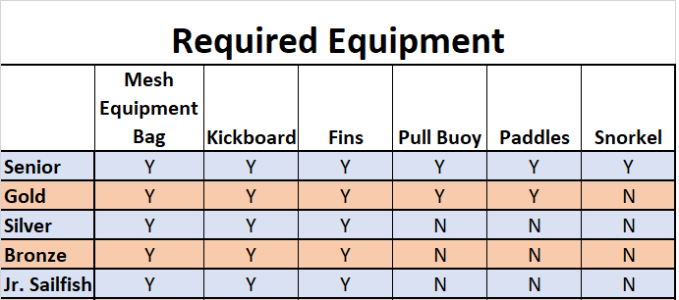

Goggles
Groups: ALL
Avoid anything like a scuba mask. Gasket-style. Avoid extra buckles or straps

Training and Competition Suits
Groups: ALL
Tighter-fitting, without ruffles or flapping material.
Jammer or brief for boys. 1-piece (while indoors) for girls.

Mesh Equipment Bag
Groups: ALL
Nothing too special here. Ideally, the bag will have a place to write the swimmer’s name on it in Sharpie.
Kickboards
Groups: ALL
Rigid foam style. Avoid cloth-covered or cartoony stuff. Be sure to sharpie your swimmer’s name on it.

Fins
Groups: ALL
When in doubt, shorter is better than longer. No scuba fins (super long, often have a buckle at the heel), nothing that looks like it would fit in at a Little Mermaid party. Be sure to sharpie your swimmer’s name on them.
Pull Buoys
Groups: Senior, Gold, Masters
Pretty standard. If your child is pretty small, be sure to get them a child’s size buoy, rather than adult. Sharpie their name on it.

Paddles
Groups: Senior, Gold, Masters
Sizing is SUPER important. Err on the side of too small, rather than too large. Paddles that are too big can cause shoulder injuries.
Measure your swimmer’s hand from the heel of the hand to the tip of the middle finger. The paddle should be no more than 1cm larger than that measurement. Paddles should be flat and rigid. Not contoured or especially flexible. Sharpie their name on them.
Snorkel
Groups: Senior ONLY
These are NOT scuba snorkels.
I strongly recommend getting one with a valve, rather than a solid tube. It’s much easier to clear water with those. Sharpie their name on it.

